FUNCTIONS AND THEIR GRAPHS
Pearson Edexcel - Tuesday 19 May 2020 - Paper 1 (Non-Calculator) Higher Tier
1.
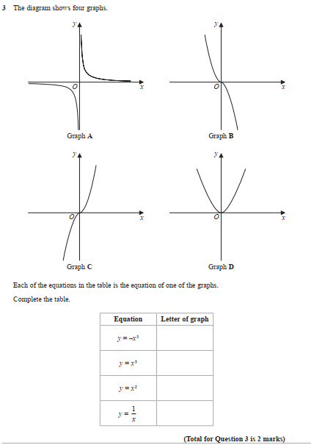

Pearson Edexcel - Tuesday 11 June 2019 - Paper 3 (Calculator) Higher Tier
2.
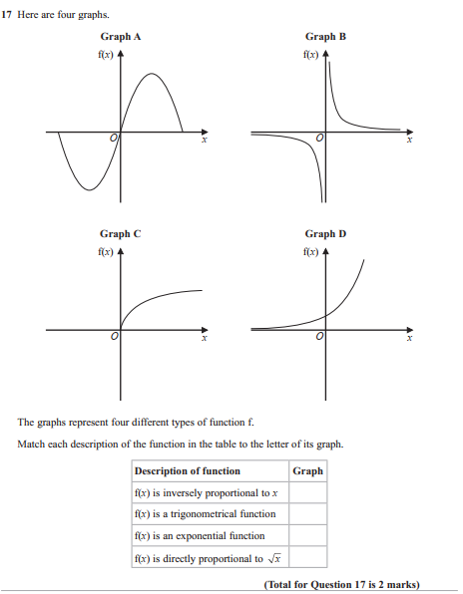

Pearson Edexcel - Thursday 8 June 2017 - Paper 2 (Calculator) Higher Tier
3.
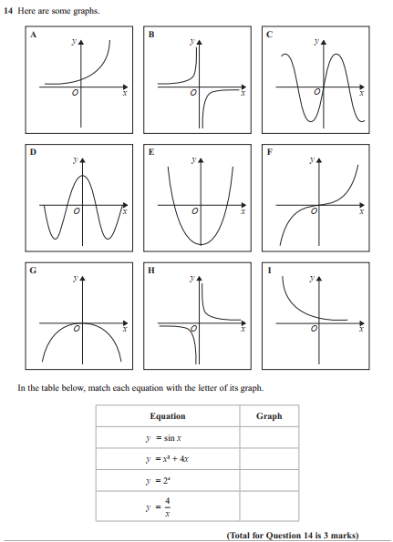
Pearson Edexcel - Specimen Papers Set 1 - Paper 1 (Non-Calculator) Higher Tier
4.
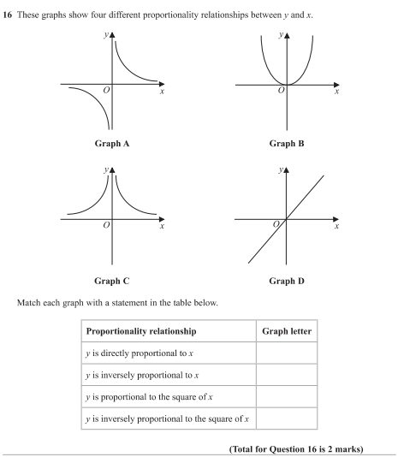

Pearson Edexcel - Friday 2 March 2012 - Paper 3 (Non-Calculator) Higher Tier
5.
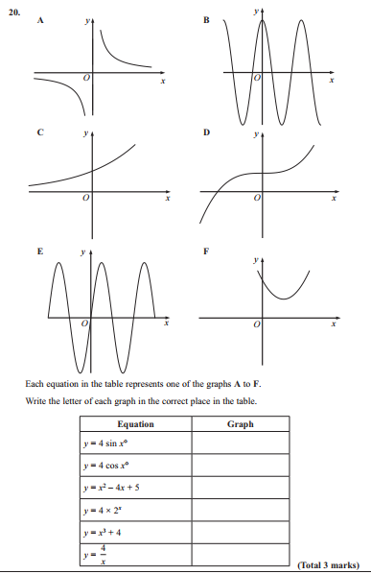

Pearson Edexcel - Friday 12 November 2010 - Paper 4 (Calculator) Higher Tier
6.
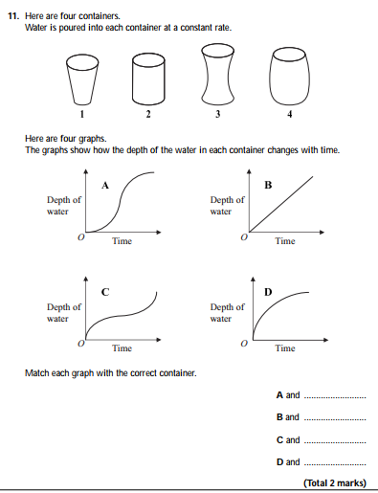
OCR GSCE – Thursday 5 November 2020 – Paper 5 (Non-Calculator) Higher Tier
7.
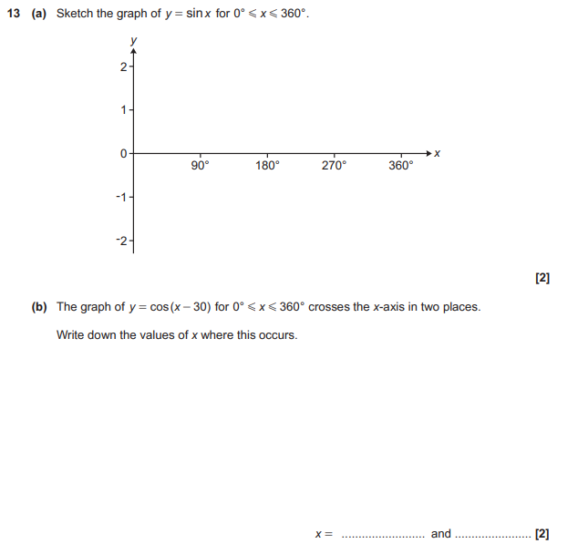

OCR GSCE – Tuesday 2 November 2017 – Paper 4 (Calculator) Higher Tier
8.
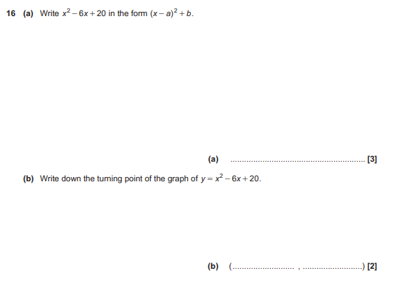
OCR GSCE – Thursday 25 May 2017 – Paper 4 (Calculator) Higher Tier
9.
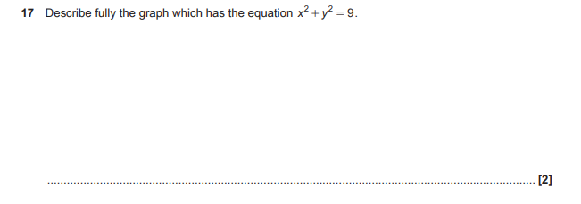

OCR GSCE – Thursday 8 June 2017 – Paper 5 (Non - Calculator) Higher Tier
10.
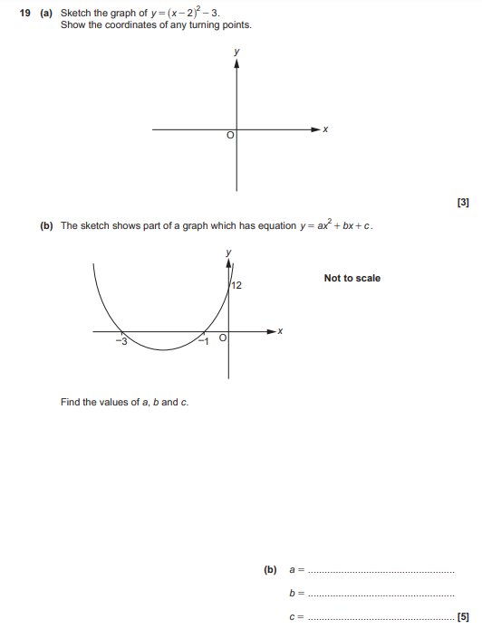

AQA GSCE – Thursday 4 June 2020 – Paper 2 (Calculator) Higher Tier
11.
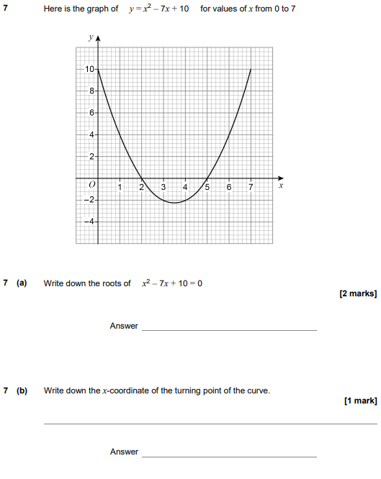

AQA GSCE – Thursday 4 June 2020 – Paper 2 (Calculator) Higher Tier
12.
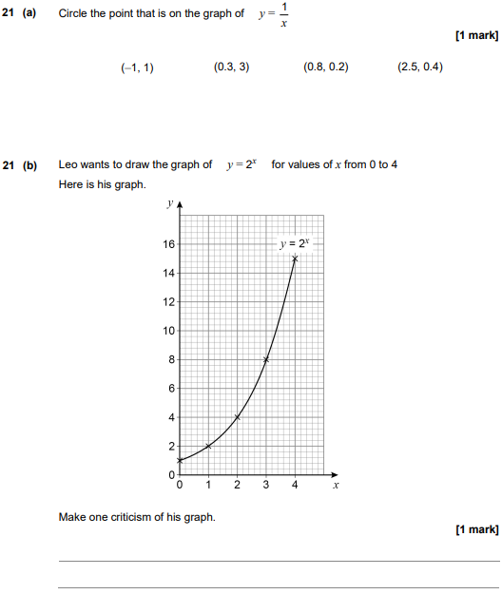

AQA GSCE – Thursday 4 June 2020 – Paper 2 (Calculator) Higher Tier
13.
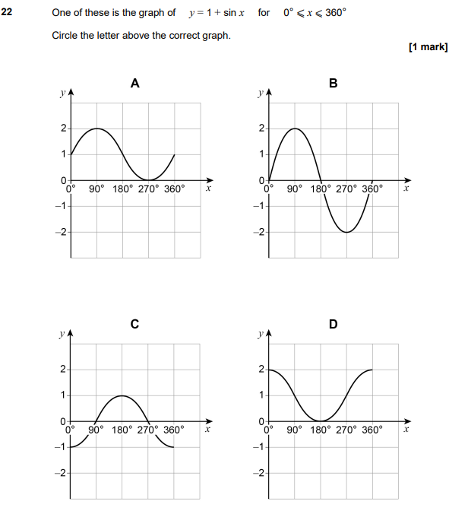

AQA GSCE – Thursday 8 June 2020 – Paper 3 (Calculator) Higher Tier
14.
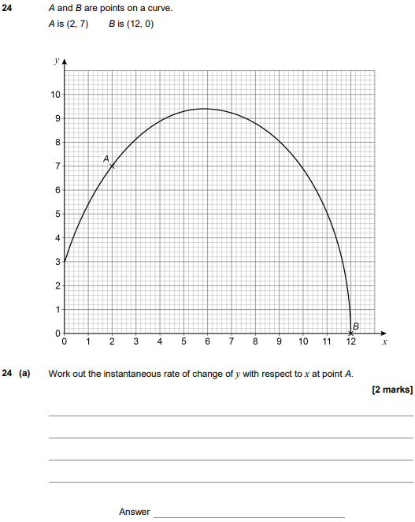
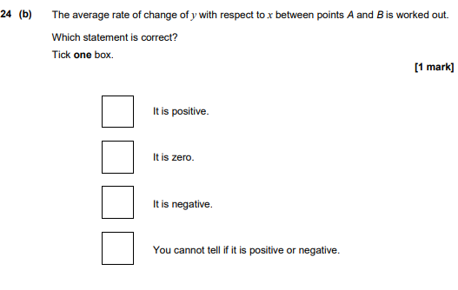
AQA GSCE – Tuesday 11 June 2019 – Paper 3 (Calculator) Higher Tier
15.
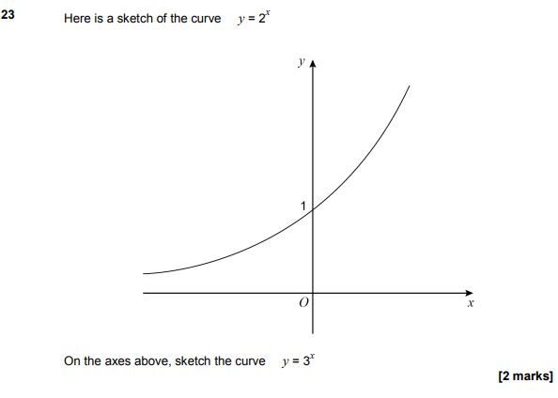

AQA GSCE – Monday 12 November 2018 – Paper 3 (Calculator) Higher Tier
16.
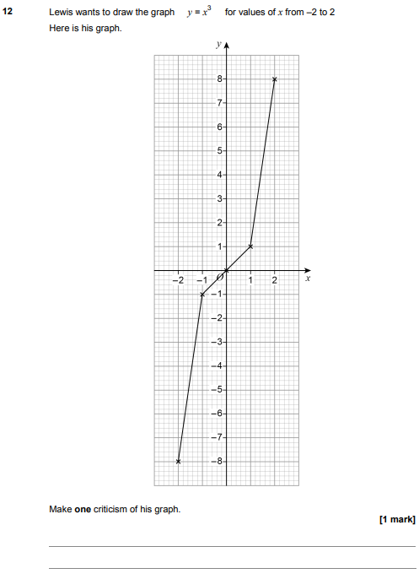

AQA GSCE – Monday 24 May 2018 – Paper 1 (Non - Calculator) Higher Tier
17.
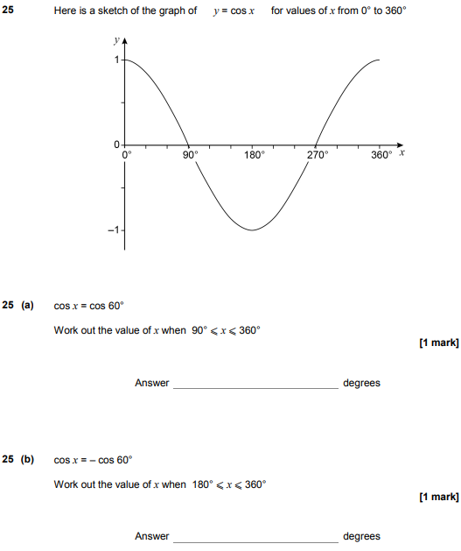

AQA GSCE – Tuesday 13 June 2017 – Paper 3 (Calculator) Higher Tier
18.
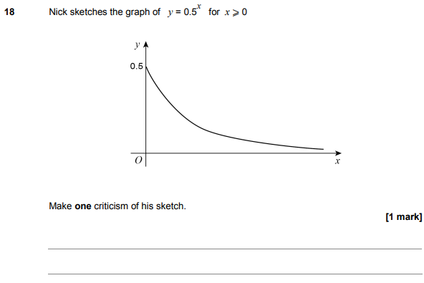

AQA GSCE – Sample Paper 1 (Non - Calculator) Higher Tier
19.
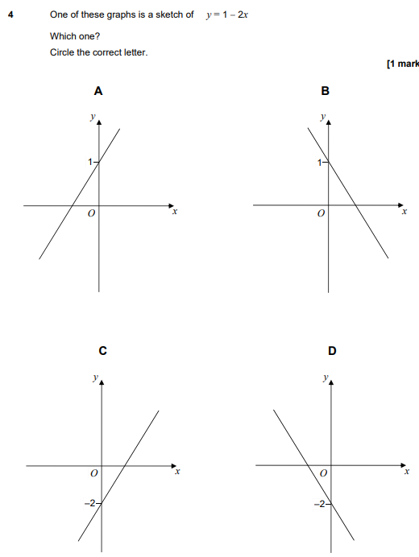

AQA GSCE – Sample Paper 3 (Calculator) Higher Tier
20.
